What is JVM?
It is:
- A specification where working of Java Virtual Machine is specified. But implementation provider is independent to choose the algorithm. Its implementation has been provided by Sun and other companies.
- Runtime Instance
- When a java application starts, a runtime instance of JVM is created. When the application completes, the instance terminates.
- If you start three java applications at the same time, on the same computer, you will get three java virtual machine instances running
- Each java application runs inside its own java virtual machine.

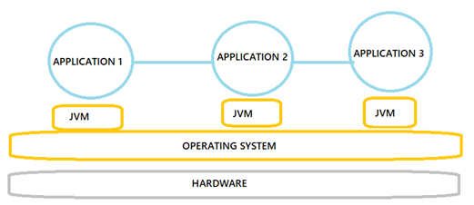

JVM will be destroyed under 2 circumstances such as,
- If there are no non-daemon threads running. At that moment, the JVM will forcefully terminate all the active daemon threads.
- If the Java app kills itself (by calling System.exit() method).
and obviously, JVM will be destroyed if it crashes.

- What it does?
The JVM performs following operation:
- Loads code
- Verifies code
- Executes code

